

MID-TERM PROJECT/TRAINING REPORT
OF

PROJECT, UNDERTAKEN

*AT

CHITKARA UNIVERSITY

IN

Department of Computer Science Engineering

ON

“FoodieHub – FoodieHub is an online food ordering app”

SUBMITTED IN PARTIAL FULFILLMENT OF THE DEGREE
OF

BE(CSE)

Submitted By:
Name: Kausik Kumar Sahoo
University ID No.: 2211981197

Chitkara University, Himachal Pradesh

      - ACKNOWLEDGEMENT
I would like to express my sincere gratitude to my faculty mentor for their continuous guidance, encouragement, and support throughout the development of this project. Their valuable suggestions and constructive feedback helped me improve both the technical and conceptual aspects of the project.
I am also thankful to Chitkara University for providing me with the opportunity to work on this project as part of the Industry-Oriented Hands-on Experience (CS253). This initiative has allowed me to gain practical exposure and understand real-world application development.
I would also like to thank my peers and all those who directly or indirectly contributed to the successful completion of this project. This experience has significantly enhanced my problem-solving skills and technical knowledge in full-stack development.
.

- PREFACE
This report presents the work carried out during the mid-term phase of the project titled “FoodieHub – Online Food Delivery Platform”. The project is developed as part of the academic curriculum to gain practical exposure in designing and building scalable web applications.
The primary aim of this project is to develop a centralized platform that simplifies the process of ordering food online, restaurant management, and order tracking. The report includes detailed information about technologies used, system design, modules implemented, and testing procedures followed.

- CONTENTS
S.No | Topics | Page No.
1 | Introduction | 4
2 | Feasibility Study / Technologies | 4, 5
3 | Requirement Analysis | 5
4 | Modules Completed | 6
5 | Detailed Analysis | 6, 7
6 | Flowchart | 7
7 | Testing | 8
7 | Bibliography | 8, 9

- INTRODUCTION TO PROJECT
The “FoodieHub – Online Food Delivery Platform” is a web-based application designed to provide a centralized platform for ordering food online. It enables seamless interaction between customers and restaurants by providing tools for browsing menus, placing orders, and tracking deliveries.
In today’s fast-paced world, online food delivery has become an essential service. However, traditional systems often lack efficiency, real-time tracking, and proper management. This project addresses these challenges by creating a structured and efficient food delivery system.
The system allows users to register, browse restaurants, select food items, place orders, and track delivery status. Restaurant owners can manage menus, update food items, and monitor orders through a dedicated dashboard.

4.1 Objectives
4.1.1 To develop a centralized and user-friendly food delivery platform
4.1.2 To simplify food ordering and restaurant management processes
4.1.3 To implement secure authentication and role-based access control
4.1.4 To enable real-time order tracking and status updates
4.1.5 To build a scalable system that can handle multiple users and restaurants

4.2 Field of the Project
4.2.1 Web Development – Designing responsive and interactive user interfaces
4.2.2 Full Stack Development – Integrating frontend, backend, and database
4.2.3 E-Commerce Applications – Enhancing online ordering experience

- FEASIBILITY STUDY / TECHNOLOGIES
5.1 Frontend Technologies
5.1.1 React.js (Vite) – Used for building fast and dynamic user interfaces
5.1.2 Tailwind CSS – Used for designing responsive and modern UI
5.2 Backend Technologies
5.2.1 Node.js – Provides server-side runtime environment
5.2.2 Express.js – Used to build RESTful APIs
5.3 Database
5.3.1 MongoDB – Stores user, order, and restaurant data
5.3.2 Mongoose – Helps in schema modeling
5.4 Authentication
5.4.1 Authentication is implemented using MongoDB, where user credentials are securely stored and verified during login.
5.5 Deployment
    - Vercel – Used for deploying and hosting the frontend and backend applications
5.6 Feasibility Analysis
The system is technically feasible as all technologies used are modern and scalable. Economically, it is cost-effective as most tools are free or open-source. Operationally, the system is user-friendly for both customers and restaurant owners.

- REQUIREMENT ANALYSIS
6.1 Functional Requirements
6.1.1 User registration and login
6.1.2 Role-based access (customer and restaurant owner)
6.1.3 Menu creation, update, and deletion by restaurants
6.1.4 Food browsing and ordering by customers
6.1.5 Order tracking and delivery status updates
6.1.6 Dashboard for managing orders and analytics

6.2 Non-Functional Requirements
6.2.1 Security – Secure transactions and data protection
6.2.2 Scalability – Support large number of users and orders
6.2.3 Performance – Fast loading and response time
6.2.4 Usability – Simple and intuitive UI
6.2.5 Reliability – Continuous system availability
- MODULES COMPLETED / KEY TAKEAWAYS
Modules Completed
7.1 Authentication Module – Login and signup functionality
7.2 Menu Management Module – Add and manage food items
7.3 Order Module – Place and manage orders
7.4 Dashboard Module – Display order data and analytics
7.5 API Integration – Frontend-backend communication
Key Takeaways
7.6 Learned full-stack development
7.7 Improved REST API design skills
7.8 Gained experience with databases
7.9 Learned authentication and authorization
7.10 Understood deployment process

- DETAILED ANALYSIS OF MODULES
8.1 Authentication Module
Ensures secure login and user registration using Clerk authentication and role-based access.
8.2 Menu Management Module
Allows restaurant owners to add, update, and delete food items and manage menus.
8.3 Order Module
Enables users to place food orders and track order status.
8.4 Dashboard Module
Displays order statistics, revenue, and performance insights for restaurant owners.
- Flowchart
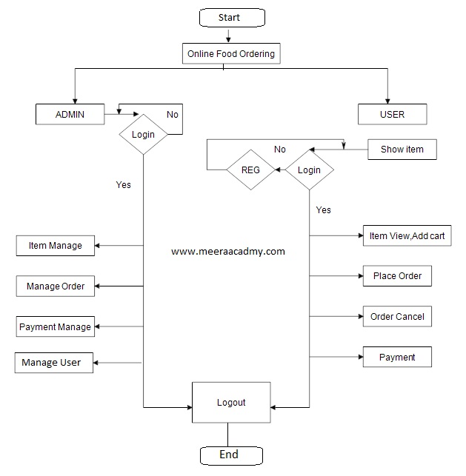
- TESTING (TEST CASES)
Test Case 1:
Input: Valid login credentials
Expected Output: User logs in successfully
Test Case 2:
Input: Invalid login credentials
Expected Output: Error message displayed
Test Case 3:
Input: Valid course creation data
Expected Output: Course should be created successfully
Test Case 4:
Input: Empty fields in form
Expected Output: Validation error should be shown
Test Case 5:
Input: Valid enrollment request
Expected Output: Student should be enrolled in course

- BIBLIOGRAPHY AND REFERENCES
Websites
https://react.dev
https://nodejs.org
https://mongodb.com
https://vercel.com
https://clerk.dev
Documentation
React Official Documentation
Node.js Documentation
MongoDB Documentation
Learning Platforms
Udemy
Coursera
Udacity

